**Note:** Students must acknowledge (i.e., through citation, through attribution, by reference, and/or through acknowledgment in bibliographic entry) the source or author of any and all information or evidence taken from the work of someone else. This includes any images, video, or music that might be incorporated into a computational artifact, and the use of program code written by another person. Taking effect beginning in the 2017-18 academic year, a student who fails to acknowledge the source or author of any and all information or evidence taken from the work of someone else will receive a score of 0 on that particular component of the performance assessment.

For information about the points this response earned, please see the [Explore High Commentary](https://secure-media.collegeboard.org/digitalServices/pdf/ap/high-explore-sample-commentary.pdf).

## 1. Computational Artifact

Your computational artifact must provide an illustration, representation, or explanation of the computing innovation's intended purpose, its function, or its effect. The computational artifact must not simply repeat the information supplied in the written responses and should be primarily nontextual.

Submit a video, audio, or PDF file. Use computing tools and techniques to create one original computational artifact (a visualization, a graphic, a video, a program, or an audio recording). **Acceptable multimedia file types include .mp3, .mp4, .wmv, .avi, .mov, .wav, .aif, or .pdf format. PDFs must not exceed three pages. Video or audio files must not exceed 1 minute in length and must not exceed 30MB in size.**

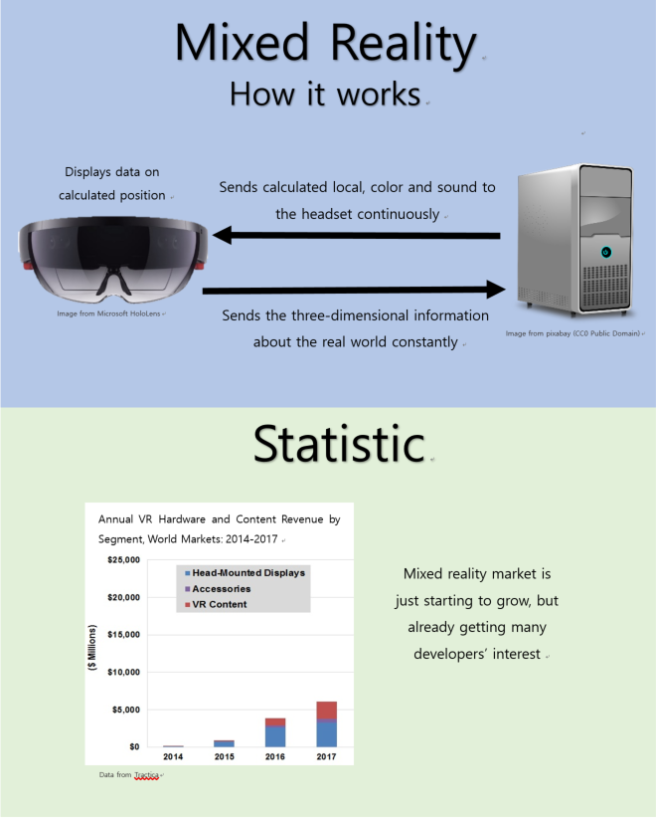

## 2. Written Responses

Submit one PDF file in which you respond directly to each of the prompts below. **Clearly label your responses 2a–2e in order.** Your responses must provide evidence of the extensive knowledge you have developed about your chosen computing innovation and its impact(s). Write your responses so they would be understandable to someone who is not familiar with the computing innovation. Include citations, as applicable, within your written responses. **Your response to prompts 2a–2d combined must not exceed 700 words.** The references required in 2e are not included in the final word count.

**2a. Provide information on your computing innovation and computational artifact.**

* Name the computing innovation that is represented by your computational artifact.
* Describe the computing innovation's intended purpose and function.
* Describe how your computational artifact illustrates, represents, or explains the computing innovation's intended purpose, its function, or its effect.

*(Approximately 100 words)*

The computing innovation that is represented by my computational artifact is that of mixed reality. Mixed reality is using technology to create a hologram representing a three-dimension graphic data from the computer on top of objects in real world. The artifact attached with this start by going through the basic functions allow mixed reality to work. With the computer and hololens transferring information back and forth constantly. The bottom part goes more associate with the growing industry of part of the mixed reality market, which is virtual reality, that it is growing in fast and constant rate. (97 words)

**2b. Describe your development process, explicitly identifying the computing tools and techniques you used to create your artifact. Your description must be detailed enough so that a person unfamiliar with those tools and techniques will understand your process.**

(Approximately 100 words)

Since word document file is easy to convert into PDF file, I used it for creating my artifact. I made two rectangular blocks that separates the information about the function of mixed reality and the statistic about the growth of vr industry. Then I chose picture of “Microsoft hololens” from the Microsoft product website and picture of computer from pixabay and made a circle with all the explanations out of it. After the first block is done, I researched some graphs that can show the importance of mixed reality and its potential influence. (93 words)

**Computing Innovation**

**2c. Explain at least one beneficial effect and at least one harmful effect the computing innovation has had, or has the potential to have, on society, economy, or culture.**

*(Approximately 250 words)*

A beneficial effect that mixed reality has on society is the ability to display a three-dimensional model comparing to the real-world object and matching with it. Three-dimensional models normally need a lot of previous printing to test whether it really fits with the model or not. However, when the model is matched with the real object through mixed reality that steps are no longer needed. This can reduce a lot of money spend on developing parts needed for the product.(5) Another benefit is that now there is another way of communicating with the computer is available. People who work for modeling, constructing, designing and drawing now can work on the object directly through the hologram install of giving a two-dimensional information to the computer. This speed up the works of the people who are directly related with the development of the culture.(2) However, there are also side effect that can be predicted. The time magazine “spoke with several optometry and eye specialists” that long term use of mixed reality can ruin our eyes. Especially for the children below 14 damage to the eyes could be very serious.(4) (187 words)

**2d. Using specific details, describe:**

* the data your innovation uses;
* how the innovation consumes (as input), produces (as output), and/or transforms data; and
* at least one data storage concern, data privacy concern, or data security concern directly related to the computing innovation.

*(Approximately 250 words)*

The kind of data that mixed reality use would primary be visual representation with RGB values, user input such as environmental object’s three-dimensional value, three-dimensional location of the machine, view direction of the user, motion of the user, sound collected from the environment, sound collected from the user, and sound files that is from the program. The hololens collects three-dimensional data of the objects in its view and send it to the computer. Then the computer converts the original non-real objects’ locational data to fit on the objects that is selected. When user gives input such as commands through his/her motion or sound, then the computer sends the data to the hololens to display the three-dimensional hologram that can be seem from the user’s view. Moreover, the views can be changed through the command and calculation is constantly made through the locational data the machine provides.(2) Since the machine constantly gives three-dimensional data of the objects in the user’s view, hacker’s attack can be deadly. Not only privacy such as names and age are exposed, but also the constant image capture from the lens and information about the shape of house and user’s body shape can be hacked.(4) (198 words)

**References**

**2e. Provide a list of at least three online or print sources used to create your computational artifact and/or support your responses to the prompts provided in this performance task.**

* At least two of the sources must have been created after the end of the previous academic year.
* For each online source, include the permanent URL. Identify the author, title, source, the date you retrieved the source, and, if possible, the date the reference was written or posted.
* For each print source, include the author, title of excerpt/article and magazine or book, page number(s), publisher, and date of publication.
* If you include an interview source, include the name of the person you interviewed, the date on which the interview occurred, and the person's position in the field.
* Include citations for the sources you used, and number each source accordingly.
* Each source must be relevant, credible, and easily accessed.

1 <https://www.fool.com/investing/2016/11/27/10-augmented-reality-stats-that-will-blow-you-away.aspx>, Leo Sun, “10 Augmented Reality Stats That Will Blow You Away,” source: Motley Fool, date viewed: 5/05/17, posted 11/27/16

2 <https://www.youtube.com/watch?v=xgakdcEzVwg>, Kotaku, “Minecraft Hololens demo at E3 2015 (amazing!),” source: Youtube, date viewed 4/30/17, posted 6/15/15

3 <http://www.hypergridbusiness.com/2015/07/virtual-reality-market-to-reach-22-billion-by-2020/>, Maria Korolov, “Virtual reality market to reach $22 billion by 2020,” source: Hypergrid Business, date viewed 4/27/17, posted 7/29/15

4 <https://www.privatetunnel.com/home/safety-risks-of-mixed-reality/>, “Safety Risks of Mixed Reality,” source: Private Tunnel, date viewed 4/20/17

5 <https://www.microsoft.com/en-us/hololens/hardware>, “A new way to see world,” source: Mircrosoft17, date viewed 4/29/17, posted 11/02/16